**Template and instructions**

**for writing contribution abstracts to VSBI 2024**

First Author1, Second Author1, Third Author2

1First Affiliation, 2Second Affiliation

This document is a template for abstracts submitted to Visegrad Symposium on Biomolecular Interactions 2024. The word-processor (ODT, DOCX and RTF) source files can be found on the conference web site, <https://vsssb.eu/2024/contribution.html>[.](http://physics.mff.cuni.cz/kchfo/MIB23/contribution.htm)

The entire abstract should fit on a single page, including text, tables, figures, keywords, and references. The page layout and spacing of the template should not be changed, and excessive additional formatting (changing fonts, bold and italic text) is strongly discouraged. The entire text should be written in 12 pt size.

|  |  |  |  |
| --- | --- | --- | --- |
|  | Column 1 | Column 2 | Column 3 |
| Row 1 | α | β | γ |
| Row 2 | α | β | γ |

Table 1: Table caption

Any tables and figures should usually span the entire width of the text and be centered on the page. Table and figure captions should also be written in 12 pt size, centered below the table or figure.

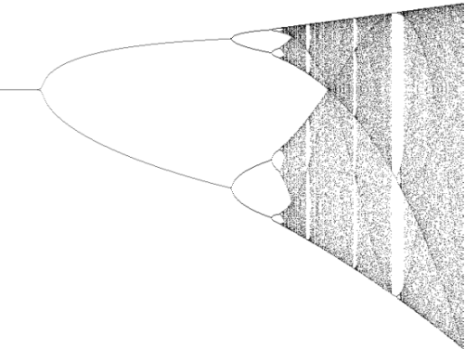

Figure 1: Figure caption

If a table or figure needs to be wrapped by text (due to an unconventional shape, or to fit more text on the page), it should take up less than half the width of the page. The abstract, including figures, must be greyscale only. Figures should be large enough so that all details are clearly visible, and include only embedded graphic files (no other inline documents) in one of the following formats: BMP, JPG, GIF, PNG, SVG, EPS, PS, PDF.

Equations should span the entire width of the text and occur where they are referred to. They should be written in the same size as the main text and be numbered in parentheses, for example:

$M_{kln}={Ae}^{iωt}\frac{1−x}{\sin^{2}\left(x\right)}$ (1)

Acknowledgments and a maximum of four references should be placed at the bottom of the page as shown below. References should be listed in the order in which they appear in the text.

**Acknowledgments:** Support from EU grant No. 12345 is acknowledged. Calculations were performed at the Wroclaw Centre for Networking and Supercomputing.

[1] Jackson, M.; Webster, A.B. *Curr. Org. Chem.* **2000**, *11* (5), 123–456.